Specialized Spelling Dictionary

What is Specialized Dictionary
# Source: AI Source: Provided by: [Data Path: Persons Table -> ID Column: 1, Name_En Column: Motasem Essam] -> From: [Chatgpt (GPT-4-turbo)] on [7/30/2025]
A Specialized Spelling Dictionary focuses on the correct spelling of terms used in a specific subject, profession, or technical field, such as medicine, law, science, engineering, or business. These dictionaries are tailored for accuracy and consistency in specialized writing and communication.

✅ Key Features:
# Source: AI Source: Provided by: [Data Path: Persons Table -> ID Column: 1, Name_En Column: Motasem Essam] -> From: [Chatgpt (GPT-4-turbo)] on [7/30/2025]
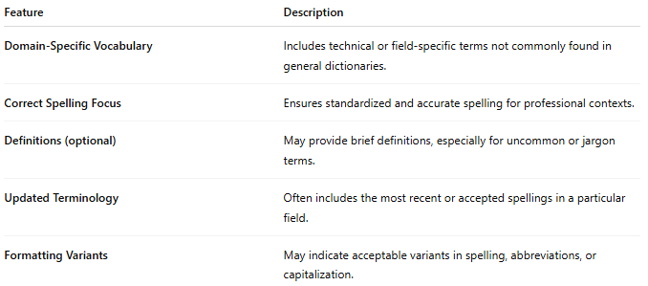
Feature | Description
Domain-Specific Vocabulary | Includes technical or field-specific terms not commonly found in general dictionaries.
Correct Spelling Focus | Ensures standardized and accurate spelling for professional contexts.
Definitions (optional) | May provide brief definitions, especially for uncommon or jargon terms.
Updated Terminology | Often includes the most recent or accepted spellings in a particular field.
Formatting Variants | May indicate acceptable variants in spelling, abbreviations, or capitalization.

👤 Target Audience:
# Source: AI Source: Provided by: [Data Path: Persons Table -> ID Column: 1, Name_En Column: Motasem Essam] -> From: [Chatgpt (GPT-4-turbo)] on [7/30/2025]
- Professionals (doctors, lawyers, scientists, engineers)
- Researchers and academic writers
- Students in technical fields
- Editors of technical documents or industry publications

📘 Examples:
# Source: AI Source: Provided by: [Data Path: Persons Table -> ID Column: 1, Name_En Column: Motasem Essam] -> From: [Chatgpt (GPT-4-turbo)] on [7/30/2025]
- Stedman’s Medical Spelling Dictionary
- Legal Spelling Dictionary
- Science and Technology Spelling Reference
- Pharmaceutical Spelling Guide

🟢 Benefits:
# Source: AI Source: Provided by: [Data Path: Persons Table -> ID Column: 1, Name_En Column: Motasem Essam] -> From: [Chatgpt (GPT-4-turbo)] on [7/30/2025]
- Ensures precision in field-specific writing
- Avoids spelling inconsistencies in professional documents
- Saves time by filtering only relevant terminology

🔴 Limitations:
# Source: AI Source: Provided by: [Data Path: Persons Table -> ID Column: 1, Name_En Column: Motasem Essam] -> From: [Chatgpt (GPT-4-turbo)] on [7/30/2025]
- Not suitable for general-purpose use
- May require updates as technical language evolves
- Can be overly technical for casual users or learners

